**PIZZA SALES SQL QUERIES**

1. **KPI’s**
2. **Total Revenue :**

Select SUM(total_price) as Total_Revenue from pizza_sales;  
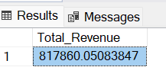

1. **Average order value :**

Select SUM(total_price)/ COUNT(Distinct order_id) as Avg_Order_Value from pizza_sales;  
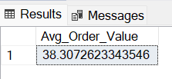

1. **Total Pizzas Sold:**

Select SUM(quantity) as Total_Pizzas_Sold from pizza_sales;  
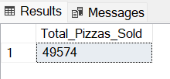

1. **Total Orders :**

Select Count(Distinct order_id) as Total_Orders from pizza_sales;

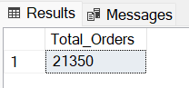

1. **Average pizza per orders:**

Select Cast(Cast(SUM(quantity) as decimal(10,2)) /

Cast(Count(Distinct order_id) as decimal(10,2)) as decimal (10,2))

as Average_pizza_per_orders from pizza_sales;

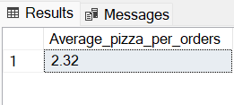

1. **Charts**
2. **Daily Trend for Total Orders**Select DATENAME(DW,order_date) as order_day , COUNT(Distinct order_id) as Total_orders from pizza_sales

group by DATENAME(DW,order_date) order by COUNT(Distinct order_id) desc

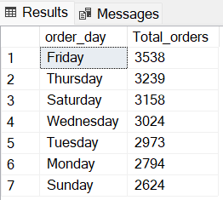

1. **Hourly Trend for total hours**

Select DATEPART(HOUR,order_time) as Order_Hour, COUNT(Distinct order_id) as total_orders

from pizza_sales

Group by DATEPART(HOUR,order_time) order by DATEPART(HOUR,order_time)  
  
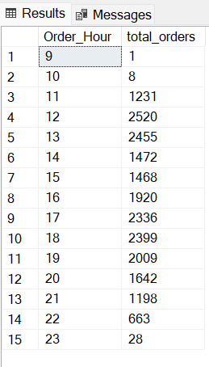

1. **Percentage of sales by pizza category**Select Pizza_Category, SUM(Total_price) as Total_Sales,

Cast(Cast(Sum(Total_Price) as decimal(10,2)) * 100 / (Select Cast(Sum(Total_Price)as decimal(10,2)) from pizza_sales)

as decimal(10,2)) as Percentage_of_Sales From pizza_sales

group by Pizza_Category

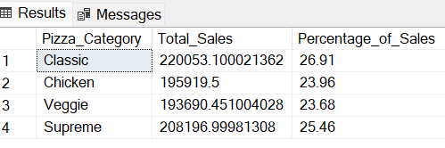

1. **Percentage of sales by pizza Size**  
   Select pizza_size, Cast(SUM(Total_price) as decimal(10,2)) as Total_Sales,

Cast(Cast(Sum(Total_Price) as decimal(10,2)) * 100 / (Select Cast(Sum(Total_Price)as decimal(10,2)) from pizza_sales)

as decimal(10,2)) as Percentage_of_Sales From pizza_sales

group by pizza_size

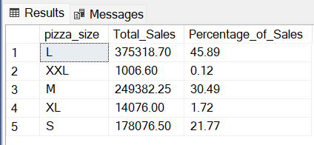

1. **Total Pizzzas Sold by Category**

Select pizza_Category , Cast(SUM(quantity) as decimal(10,2))

as Total_Pizzas_Sold from pizza_sales

Group by pizza_Category

order by SUM(quantity) desc

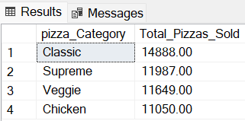

1. **Top 5 pizza sales**  
     
   Select Top 5 pizza_name, Sum(quantity) as Total_Pizzas_Sold from pizza_Sales

group by Pizza_name

order by Sum(quantity) desc  
  
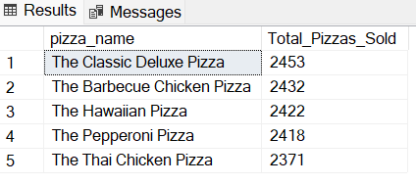

1. **Bottom 5 pizza sales**

Select Top 5 pizza_name, Sum(quantity) as Total_Pizzas_Sold from pizza_Sales

group by Pizza_name

order by Sum(quantity) Asc

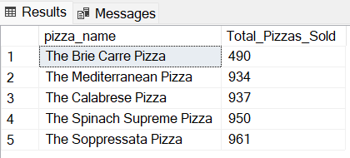

Note : *If**you want to apply the month , Quarter , week filters to the above queries you can use where clause , follow some of below examples*

Select DATENAME(DW,order_date) as order_day , COUNT(Distinct order_id) as Total_orders   
from pizza_sales  
Where MONTH(order_date) = 1   
group by DATENAME(DW,order_date)   
order by COUNT(Distinct order_id) desc  
  
*\*Here MONTH(order_date) = 1 indicates that the output is fo month of January. MONTH(order_date) = 4 indicates that the output is for month of April.*   
  
Select DATENAME(DW,order_date) as order_day , COUNT(Distinct order_id) as Total_orders   
from pizza_sales  
Where Datepart(Quarter,order_date) = 1   
group by DATENAME(DW,order_date)   
order by COUNT(Distinct order_id) desc  
  
*\*Here Datepart(Quarter,order_date) = 1 indicates that the output is for the Quarter 1. Datepart(Quarter,order_date) = 3 indicates that the output is for the Quarter 3.*